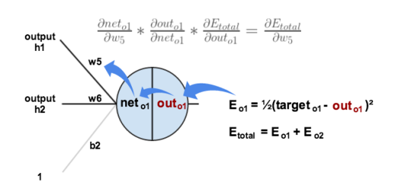

Most basic Neural Network (All formulae given above) –

1. Layout your network – Decide what each neuron must do
2. Feed inputs
3. Select Random weights and biases for each synapse and bias for every neuron
4. Net Input = Sum of the products of inputs and respective weights + bias
5. Net output = Sigmoid (net input)
6. Repeat steps 3-4 for every neuron a hidden layer
7. Repeat steps 3-5 for every hidden layer
8. Error = ½ (target – output)2
9. Back-propagation to optimize weights
10. Repeat steps 3-7 several thousand times – Training the algorithm
11. Neural network is finally optimized for that particular data set.

Neural Networks for Computer Vision –

Kill me pls

Synapses = 2 by 1

Inputs = 100 by 2

Output = 100 by 2 dot 2 by 1 = 100 by 1

Training = 100 by 1

Error = 100 by 1 - 100 by 1 = 100 by 1

Sigmoid Derivative = 100 by 1

Adjust = 2 by 100

weights = 3 by 1 + 3 by 1 = 3 by 1

Answer = 1 by 3 dot 3 by 1 = 1 by 1 = A single fucking number